**Model Development Phase**

|  |  |
| --- | --- |
| Date | 20 July 2024 |
| Team ID | Team-739867 |
| Project Title | SmartLender – Envisioning Success:  Predicting University Scores With Machine Learning |
| Maximum Marks | 4 Marks |

**Initial Model Training Code, Model Validation and Evaluation Report**

The initial model training code will be showcased in the future through a screenshot. The model validation and evaluation report will include a summary and training and validation performance metrics for multiple models, presented through respective screenshots.

**Initial Model Training Code :**

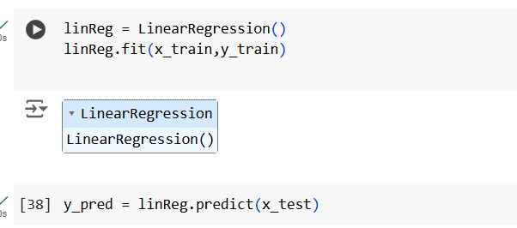

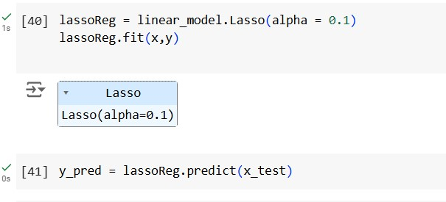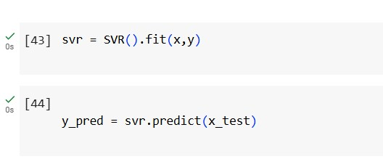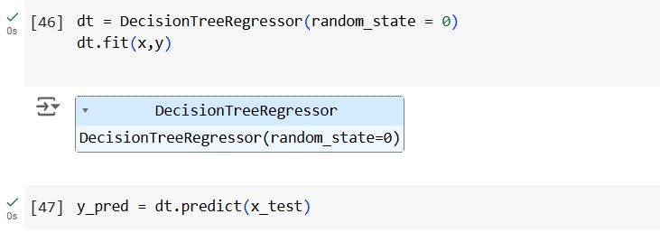

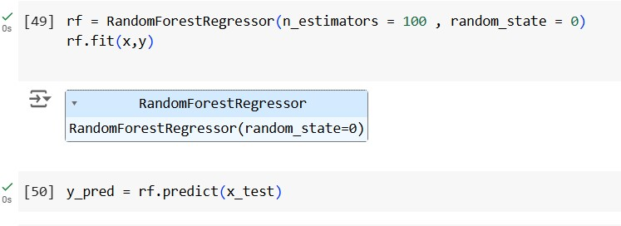

**Model Validation and Evaluation Report :**

|  |  |  |
| --- | --- | --- |
| **Model** | **Summary** | **Training and Validation Performance Metrics** |
| Linear  Regression |  |  |
| Lasso  Regression |  |  |
| Support  Vector  Machine |  |  |
| Decision Tree |  |  |

|  |  |  |
| --- | --- | --- |
| Random  Forest |  |  |